(Approx. 519 words)

How to remove GPS and other Data from Photos on Your iPhone or iPad
By Bill Crowe, Instructor, Sarasota Technology User Group, FL
July 2018 issue, STUGMonitor
www.thestug.org
wtcrowe (at) verizon.net

The general term for data saved with your picture is Exchangeable Image Format, also known as EXIF. It is a set of data that’s attached to every image you take. Most cameras and smartphones these days add basic parameters such as the mode in which the photo was taken, the shutter speed, ISO, aperture data, and even the location of the photograph. This presents a peculiar problem — when you click a picture of a beautiful bird perched on the windowsill in your house, your camera automatically adds the location of the picture, which could reveal your home address when you share it with others online. Most social networks such as Facebook, Instagram, and Twitter remove all this data from photos when you upload them. However, when your photo is shared via email, messages or cloud storage services such as Google Drive or Dropbox, this data is still present on pictures. To protect your privacy, it’s best to remove some or all of the EXIF data from images. Here’s how you can do it.


You can remove GPS info from photos on your iOS device, but you’ll need a third-party app to do so. There are a couple of options available, but here’s how to do it with the free app Photo Investigator.($2.99 for the Pro version)


1. Install the “Photo Investigator” App
2. Open the application, tap the photo icon, and allow the application access to your pictures
3. Select a photo album and then the photo you would like to view the metadata .
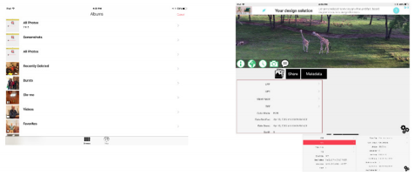

4. To see what the data looks like you can tap the various fields in the lower left box and see the data in the lower right box. I have done it here for the GPS data.
5. Tap Metadata box. You can remove all the meta data from here or edit individual items of the meta data by paying the $2.99 for the pro edition.
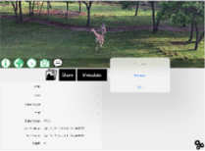
6. You will then be asked if you want to keep both the original and the modified picture or remove the original picture.
7. Now you can share the modified picture with others via email or message. By taping the share box.
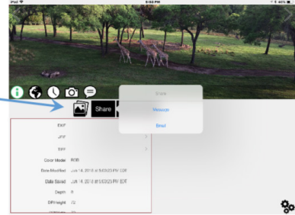
8 . To process another photo, click the photos icon.

BONUS: Keeping GPS metadata off your phone in the first place

If you want to be 100% sure that this data is removed by making sure that photos taken on your iPhone don’t have GPS info captured in the first place, you can do so by going to:
Settings / Privacy / Location Services / Camera / Never. Keep in mind that doing this will eliminate the ability to make albums based on location. Also, this setting only applies to the default Camera app; if you use a third-party camera app, it will still be allowed to tag your location in your photos unless you alter that setting as well.

Source and Compliments of igeeksblog.com

